Project Planning Phase
Project Planning Template (Product Backlog, Sprint Planning, Stories, Story points)

Date | 30 September 2026
Team ID | SWTID-2026-6606
Project Name | AI FitTrack API
Maximum Marks | 5 Marks

Product Backlog, Sprint Schedule, and Estimation (4 Marks)
Use the below template to create product backlog and sprint schedule
Sprint | Functional Requirement (Epic) | User Story Number | User Story / Task | Story Points | Priority | Team Members
Sprint-1 | Registration | USN-1 | As a user, I can register for the application by entering my email, password, and confirming my password. | 2 | High
Sprint-1 |  | USN-2 | As a user, I will receive a confirmation email once I have registered for the application. | 1 | High
Sprint-1 |  | USN-3 | As a user, I can register for the application through Gmail. | 2 | Medium
Sprint-1 | Login | USN-4 | As a user, I can log into the application by entering email and password. | 1 | High
Sprint-1 |  | USN-5 | As a user, I can reset my password through an emailed link or OTP. | 2 | Medium
Sprint-1 | Profile | USN-6 | As a user, I can create my profile with age, height, weight and fitness goal. | 3 | High
Sprint-1 | Workout Logging | USN-7 | As a user, I can log a workout (type, duration, sets, reps) through the API. | 3 | High
Sprint-1 |  | USN-8 | As a user, I can view, edit and delete my workout history. | 2 | High
Sprint-1 | Dashboard | USN-9 | As a user, I can view a daily summary of my workouts, calories and steps on my dashboard. | 4 | High
Sprint-2 | Nutrition Tracking | USN-10 | As a user, I can log my meals and see the calories and macros consumed. | 3 | High
Sprint-2 |  | USN-11 | As a user, I can search a food database to add items quickly. | 3 | Medium
Sprint-2 | Wearable Integration | USN-12 | As a user, I can connect my wearable / Google Fit account so that steps and heart rate sync automatically. | 5 | Medium
Sprint-2 | AI Recommendations | USN-13 | As a user, I receive a personalised weekly workout plan based on my profile and history. | 5 | High
Sprint-2 |  | USN-14 | As a user, I receive daily calorie and macro targets based on my goal. | 4 | High
Sprint-3 | AI Recommendations | USN-15 | As a user, my activities (walking, running, cycling) are recognised automatically from sensor data. | 5 | Medium
Sprint-3 | Progress Analytics | USN-16 | As a user, I can view weekly and monthly progress charts. | 4 | High
Sprint-3 |  | USN-17 | As a user, I can set goals and track how close I am to achieving them. | 3 | Medium
Sprint-3 | Notifications | USN-18 | As a user, I receive reminders and achievement notifications. | 3 | Low
Sprint-3 | Customer Support | USN-19 | As a user, I can raise a support ticket when I face a problem. | 2 | Medium
Sprint-3 |  | USN-20 | As a customer care executive, I can view and respond to support tickets. | 3 | Medium
Sprint-4 | User Management | USN-21 | As an administrator, I can view, block or delete user accounts. | 3 | High
Sprint-4 | Monitoring | USN-22 | As an administrator, I can monitor API usage and AI model performance. | 4 | Medium
Sprint-4 | Web Dashboard | USN-23 | As a user, I can use all main features from a web dashboard in my browser. | 5 | High
Sprint-4 | API Access | USN-24 | As a developer, I can get an API key and I am protected by rate limiting. | 4 | Medium
Sprint-4 | Deployment | USN-25 | As a team, we deploy the API to the cloud with Swagger documentation. | 4 | High

Project Tracker, Velocity & Burndown Chart: (4 Marks)
Sprint | Total Story Points | Duration | Sprint Start Date | Sprint End Date (Planned) | Story Points Completed (as on Planned End Date) | Sprint Release Date (Actual)
Sprint-1 | 20 | 6 Days | 05 Oct 2026 | 10 Oct 2026
Sprint-2 | 20 | 6 Days | 12 Oct 2026 | 17 Oct 2026
Sprint-3 | 20 | 6 Days | 19 Oct 2026 | 24 Oct 2026
Sprint-4 | 20 | 6 Days | 26 Oct 2026 | 31 Oct 2026

Velocity:
Imagine we have a 10-day sprint duration, and the velocity of the team is 20 (points per sprint). Let’s calculate the team’s average velocity (AV) per iteration unit (story points per day)

For AI FitTrack API: the sprint duration is 6 days and the team's planned velocity is 20 story points per sprint. Average velocity (AV) = 20 / 6 = 3.33 story points per day. Four sprints (80 story points) are planned from 05 Oct 2026 to 31 Oct 2026.

Burndown Chart:
A burn down chart is a graphical representation of work left to do versus time. It is often used in agile software development methodologies such as Scrum. However, burn down charts can be applied to any project containing measurable progress over time.
Planned burndown for AI FitTrack API (actual progress is added at the end of each sprint):
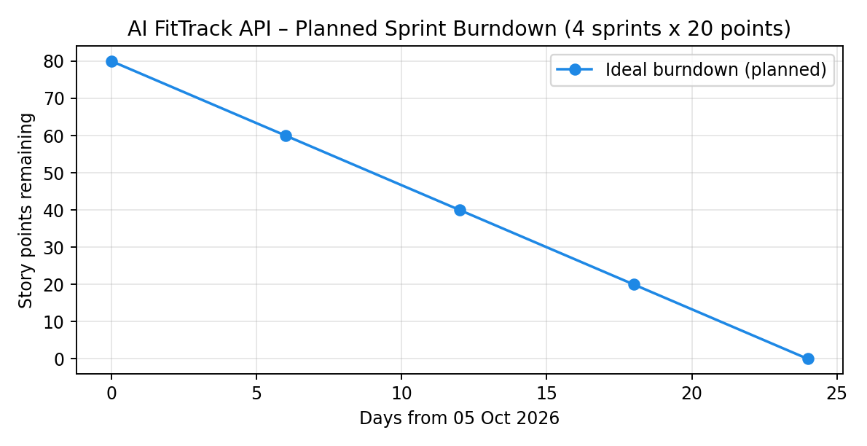

https://www.visual-paradigm.com/scrum/scrum-burndown-chart/
https://www.atlassian.com/agile/tutorials/burndown-charts

Reference:
https://www.atlassian.com/agile/project-management
https://www.atlassian.com/agile/tutorials/how-to-do-scrum-with-jira-software
https://www.atlassian.com/agile/tutorials/epics
https://www.atlassian.com/agile/tutorials/sprints
https://www.atlassian.com/agile/project-management/estimation
https://www.atlassian.com/agile/tutorials/burndown-charts

